1. **Complete the drawings below with the following words.**

Electric machine (2) – Final drive (2) – Gas engine (2) – ~~Battery pack (2)~~ – ~~Manual transmission & automated clutch~~ (2) – Integrated power electronics (2) - Generator

*-

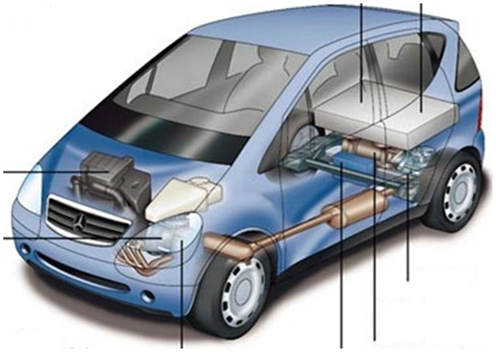

Integrated power electronics

Gas engine

Manual transmission & automated clutch

Final drive

Electric machine

Manual transmission & automated clutch

Final drive

Battery pack

Générator

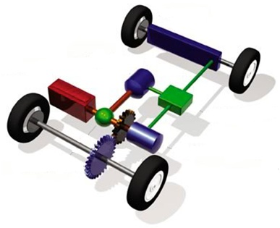

Battery pack

Gas engine

Manual transmission & automated clutch

Final drive

1. **Fill in the blanks.**

How does a hybrid car work ?

In a traditional hybrid *vehicle* , you have a complete electric car. It includes an *electric motor* to provide all of the power to the *wheels* , as well as *batteries* to supply the motor with electricity. Then you have a completely separate gasoline engine powering a *generator* .The engine is very small, perhaps 10 to 20, HORSEPOWER and it is designed to run at just one speed for *maximum* efficiency. The purpose of this small, efficient engine is to provide enough *power* for the car at its *cruising* speed. During times of  *acceleration*, the batteries provide the *extra power* necessary. When the car is decelerating or standing still, the batteries *is recharge* .This sort of *hybrid* car is essentially an electric car with a *built in* recharger for longer range. The *advantage* is that the small, efficient gasoline engine gets great mileage.

*~~batteries~~  ~~- acceleration~~ - ~~horsepower~~ - ~~wheels~~ - ~~extra power~~ - ~~generator~~ - ~~recharge~~ - ~~built-in~~ - ~~power~~ - ~~advantage~~  - ~~electric motor~~ - ~~vehicle~~ - ~~hybrid~~ - ~~maximum~~ - ~~cruising~~*

1. **Quizz**

[*http://auto.howstuffworks.com/hybrid-car-quiz.htm*](http://auto.howstuffworks.com/hybrid-car-quiz.htm)

1. **Role play**

Prepare a summary presenting the different types of hybrid cars to a customer. You have to use the following plans and Powerpoint

* **Hybride parallèle** :

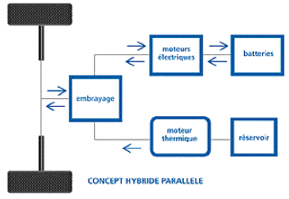

* **Hybride série :**

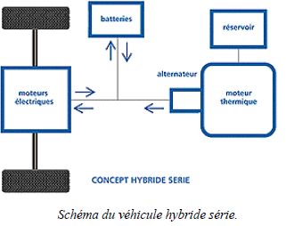

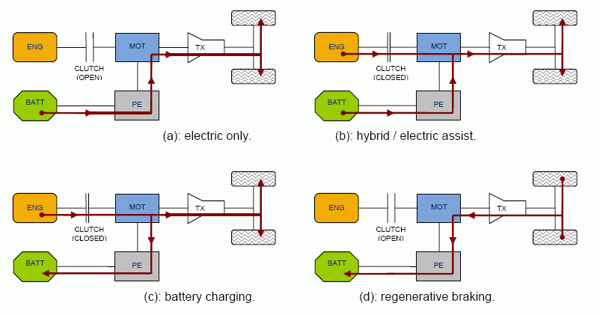

**ressources proposées :**

[*http://www.howstuffworks.com/hybrid-car.Htm*](http://www.howstuffworks.com/hybrid-car.Htm)

*http://en.wikipedia.org/wiki/Hybrid_electric_vehicle*